**Arg_quality_rank_30k.csv**

**Amount:** 30,497 arguments

**Topics:** 71 different topics

**Argument length:** minimum 35 chars. and maximum 210 chars.

**WA and MACE-P:** score functions for measuring the quality of arguments

Distribution of two score functions in the data:

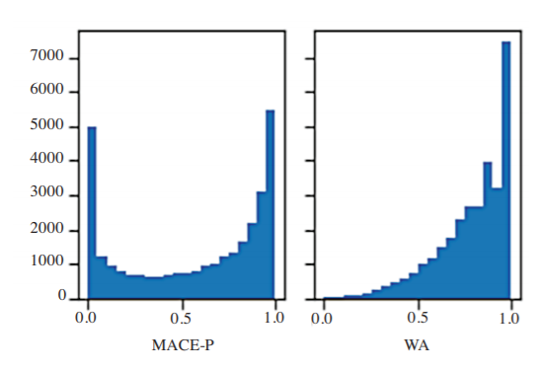

**Stance WA:**  1 (pro), -1 (con) and 0 (neutral)

**Stance WA conf:** the confidence in the stance label